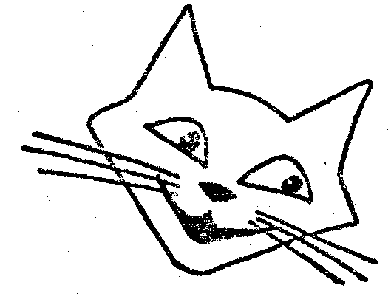

I/we wish to become a member/members of the Kentish Cat Society.
If elected, I/we agree to abide by the Society's rules and to be subject to the rules and disciplinary code
of the Governing Council of the Cat Fancy. This includes acceptance of the G.C.C.F.'s Code of Ethics.
I/we enclose....................Single £4.00. Joint £6.00.
Cheques made payable to the Kentish Cat Society please or by bank transfer, details on request.
Please write in BLOCK CAPITALS
NAME Mr/Mrs/Miss/Ms ..................................................................................................................................
ADDRESS ......................................................................................................................................................
........................................................................................................................POSTCODE.............................
TELEPHONE NUMBER ........................................................FAX...................................................................
Email address (as it appears) ..........................................................................................................................
ARE YOU A BREEDER? Yes/No YOUR OWN G.C.C.F. PREFIX (if any)......................……......................
BREEDS OF CAT OWNED: PEDIGREE .......................................................................................................
NON-PEDIGREE: ............................................................................................................................................
OTHER CAT CLUBS OF WHICH YOU ARE A MEMBER ...............................................................................
...........................................................................................................................................................................
............................................................................................................................................................................
SUBSCRIPTIONS Single ...........£4.00 Joint ............£6.00
All annual subscriptions are renewable on 1st January of each year except that new members joining at or
after our show in October will not be liable to pay a further subscription for the year immediately following.
# Your membership details will be recorded on computer. The Society is registered under the
Data Protection Act 1998 for this purpose.
SIGNATURE .............................................…………............... DATE ...............................
Please send this form with your remittance to the Treasurer Mrs A Vanns, 4 Fairfield Way, Hildenborough, Kent TN11 9ET email: anne@vanns.plus.com

Membership renewals
Kentish Cat Society 2023
Name Mr/Mrs/Miss/Ms.............................................. Tel: ............................. Date: ..........................
Address .......................................................................................................................................................
.....................................................................................................................................................................
Postcode.............................. Email: .......................................................................................................
Enclosed £ ................. Subscription £................ Donation (Cheques payable to Kentish Cat Society) ................................................................................................ Signed
Annual subs Single:.... £4.00 Joint:.... £6.00
Long term (10 year) Single: £32.00 Joint: £48.00
(after at least 3 years’ annual adult membership)

Please send this form with your remittance to the Treasurer Mrs A Vanns, 4 Fairfield Way, Hildenborough, Kent TN11 9ET email: anne@vanns.plus.com

